Name: Rahul Bhagat
Module 1 – Project: Mathematical foundation for AI/ML using the MNIST dataset

Abstract
This project focuses on the mathematical foundation for AI/ML using the MNIST dataset.
We perform eigen decomposition, apply PCA for dimensionality reduction, and assess reconstruction error using PSNR.

1 Introduction
The MNIST dataset is a comprehensive collection of handwritten digits ranging from 0 to 9.
It includes 60,000 grayscale images for training and 10,000 images for testing. Each image is 28 by 28 pixels, with pixel values ranging from 0 to 255.
In this project, we focus on analyzing a subset of the test dataset and apply Principal Component Analysis (PCA) to reduce dimensionality.

2 Tasks
Task 1: Eigen Decomposition
Compute the eigen decomposition of the sample covariance matrix. Use the eigenvalues
to calculate the percentage of variance explained. Plot the cumulative sum of these
percentages versus the number of components.
In Figure 1, we see the cumulative sum of these percentages versus the number of components.

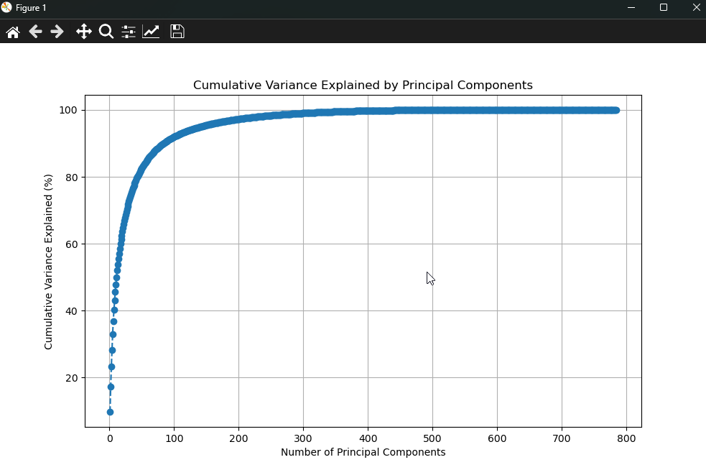

Task 2: PCA for Dimensionality Reduction
Apply PCA via eigen decomposition to reduce the dimensionality of the images for each p ∈ {50, 250, 500}.

Task 3: Data Reconstruction
Using the reduced data from Task 2, reconstruct the original images. Use the property of orthonormal matrices for reconstruction.

Below you can find the PCA results for p ∈ {50, 250, 500} and image reconstruction.

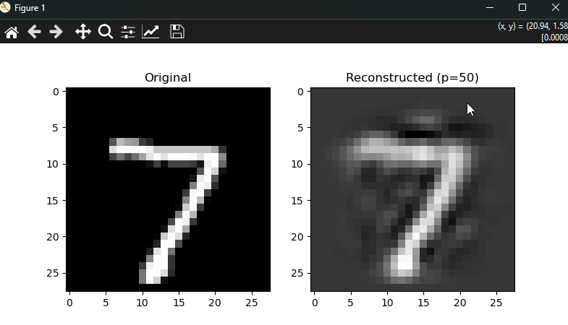
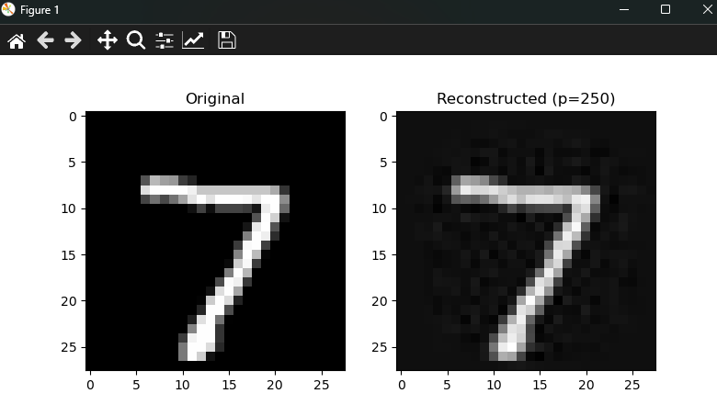
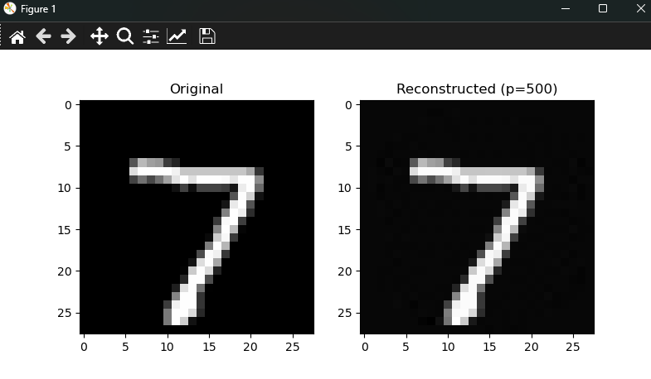

Task 4: Error Comparison (PSNR)
Compare the error between the original and reconstructed images for 5 randomly selected images using Peak Signal-to-Noise Ratio (PSNR).
The output is printed on the console for above results.
Average PSNR for p=50: 19.89 dB

Average PSNR for p=250: 30.31 dB

Average PSNR for p=500: 51.80 dB

3 Methodology
3.1 Dataset
The MNIST dataset consists of 60,000 training and 10,000 testing images. In this project, we use the first 2000 samples from the test set.
The images are scaled to the range [0, 1] by dividing each pixel value by 255.

3.2 Data Preprocessing
Each image is flattened into a vector of size 784 (28x28). A matrix X ∈ R2000×784 is created, where each row represents a flattened image.

3.3 Eigen Decomposition
We compute the sample covariance matrix of X and perform eigen decomposition. The eigenvalues represent the variance explained by each principal component.

3.4 PCA
We reduce the dimensionality of the dataset using PCA for p ∈ {50, 250, 500} and reconstruct the data using the principal components.

4 Results and Discussion
4.1 Variance Explained
The cumulative variance explained by the principal components shows that most of the variance can be captured with fewer components.

4.2 Data Reconstruction
The reconstructed images from different values of p show varying levels of detail. Higher values of p result in better reconstruction.

4.3 Error Comparison
The PSNR values indicate the reconstruction quality. Higher PSNR values suggest less reconstruction error.

5 Conclusion
In this project, we applied PCA to the MNIST dataset and successfully reduced the dimensionality while retaining most of the variance.
The reconstructed images showed good quality with minimal error, as indicated by the PSNR values.

References
1. MNIST Dataset: http://yann.lecun.com/exdb/mnist/
2. Python Peak Signal-to-Noise Ratio (PSNR): https://www.geeksforgeeks.org/python-peak-signal-to-noise-ratio-psnr/

